Question for Assignment

1. **Char** StringTokens(char*)**

Write a function which takes a string and returns an array of words in the string. For example:

String: I am a student of OOP in FAST-NU

Function StringTokens returns:

|  |
| --- |
| I  am  a  student  of  OOP  In  FAST-NU |

Hint: words are separated by spaces.

Note: Do not consume space of single extra character. Token printing is not part of this function.

Question for Quiz:

Q1:

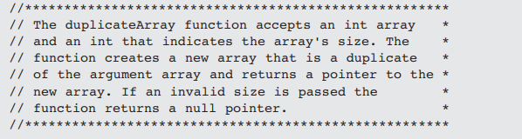

int *duplicateArray(const int *arr, int size)

{

//Write your code here

}

Q2:

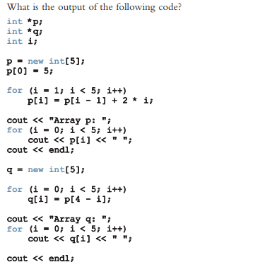

Solution for you:

